**CSE370 – Database Systems**

**Assignment 03**

**Spring 2023**

1. Convert the following ER diagrams to Schema:
2. 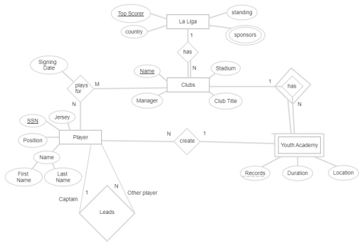
3. .